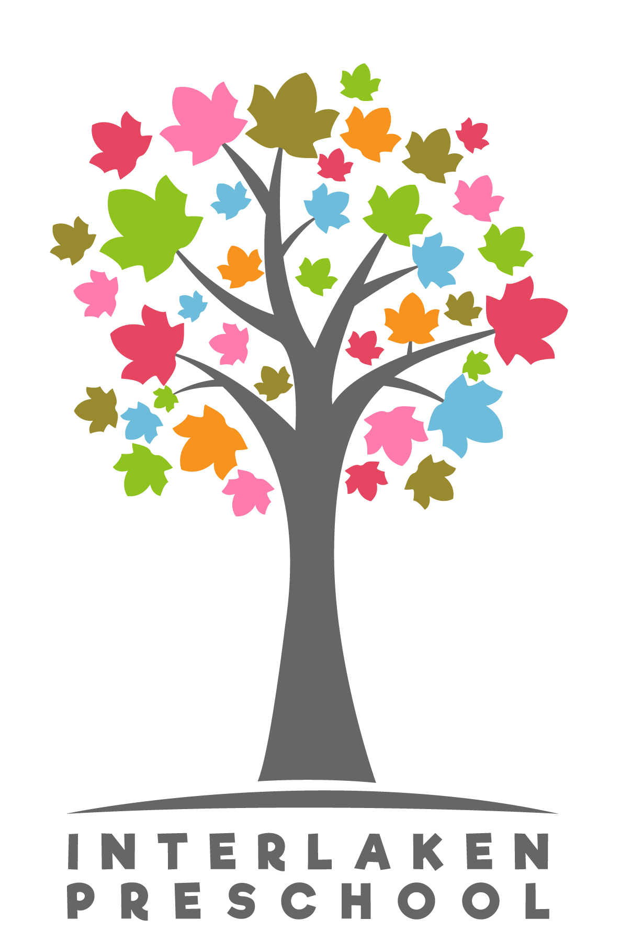

2020 – 2021 School Calendar

September 2, 2020 First Day of New School Year
September 7, 2020 Closed in observance of Labor Day
October 9, 2020 Early Closure 3:15
October 29, 2020 Virtual Curriculum Night 6:00-7:30 p.m.
November 11, 2020 Closed in observance of Veterans Day
November 13, 2020 Early Closure 3:15
November 26-27, 2020 Closed in observance of Native American Heritage Day
December 3, 2020 Virtual Kindergarten Preparedness 6:00-8:00 p.m.
December 23- 31 Closed for Winter Break
January 1, 2020 Closed in Observance of New Year’s Day
January 8, 2021 Early Closure 3:15
January 18, 2021 Closed in observance of Martin Luther King Jr.’s Day
January 21, 2021 Interlaken Preschool Open House 6:00 p.m. (perspective families)
February 12, 2021 Early Closure 3:15
February 15, 2021 Closed in observance of President’s Day
February 16, 2021 Closed for Teacher In-Service
March 12, 2021 Early Closure 3:15
April 9, 2021 Family-Teacher Conference Day *Classrooms closed.
April 23, 2021 All-School Fundraiser

May 3, 2021 Sound Child Care Solutions: UIR Professional Development
Training *Classrooms closed
May 7, 2021 Early Closure 3:15
May 14, 2021 Family-Teacher Collaborative Conference Day *Classrooms closed.
May 31, 2021 Closed in observance of Memorial Day
June 11, 2021 Early Closure 3:15
June 18, 2021 Closed for Teacher In-Service
June 25, 2021 End of Year Celebration
July 5, 2021 Closed in observance of Independence Day
July 9, 2021 Early Closure 3:15
Aug. 23 – 27, 2021 Closed for Teacher In-Service
September 1st First Day of School 2021 – 2022 School Year

